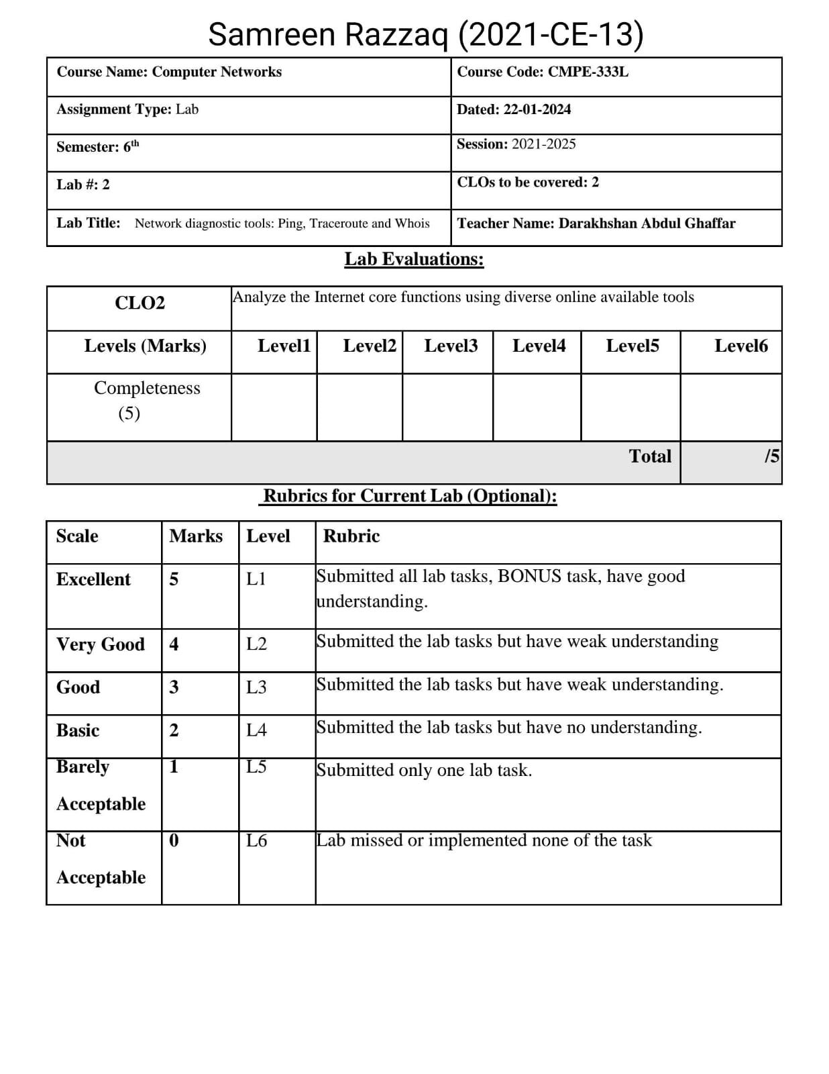

**Lab Task:**

**1.** Traceroute to the following destinations/countries choosing a specific site of your own choice

hosted in each of the mentioned countries and write down the main route from your site/country

to the destination. You are required to mention the main nodes along with country/city name.

**Solution:**

**Asia: China**

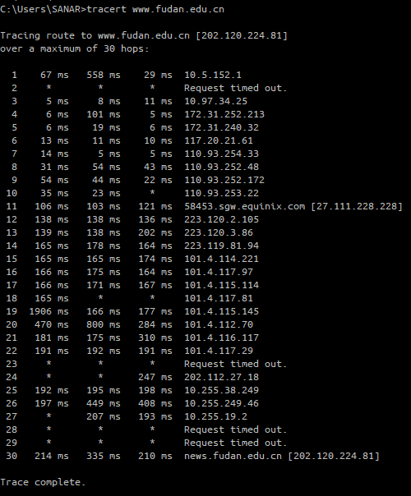****

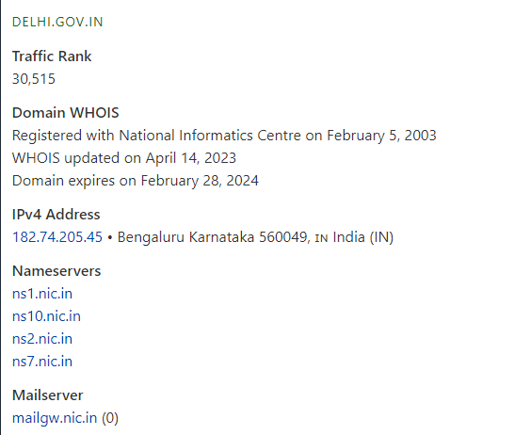**India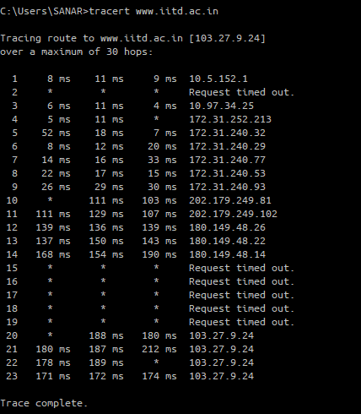:**

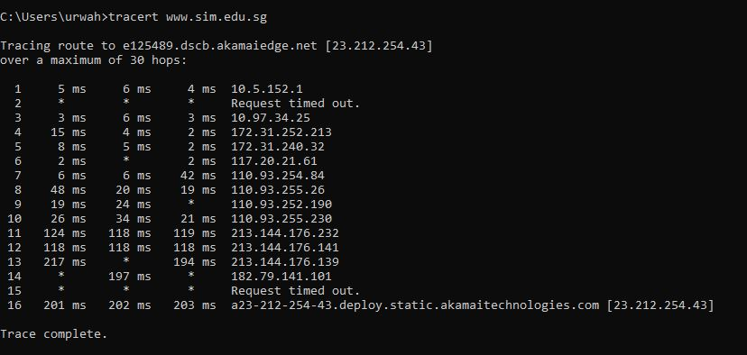**Singapore:**

**Middle East: Saudi Arabia**

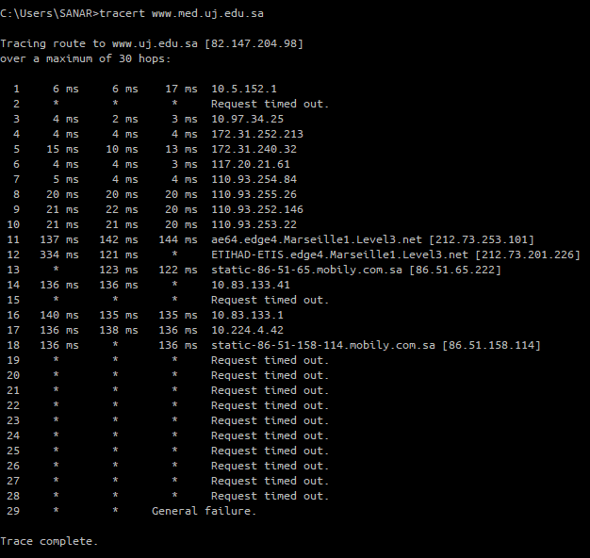

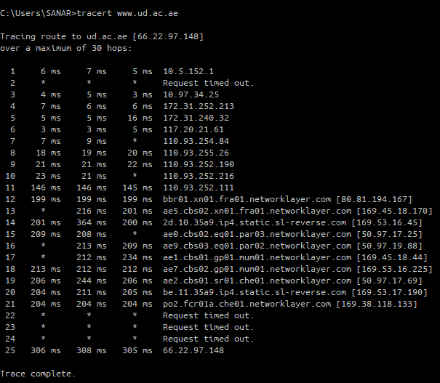**Dubai:**



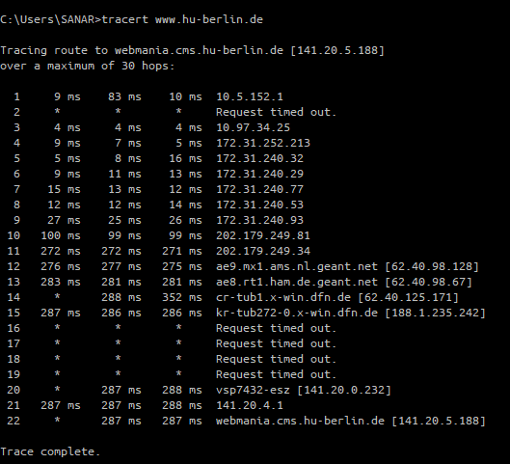**Europe: Germany**

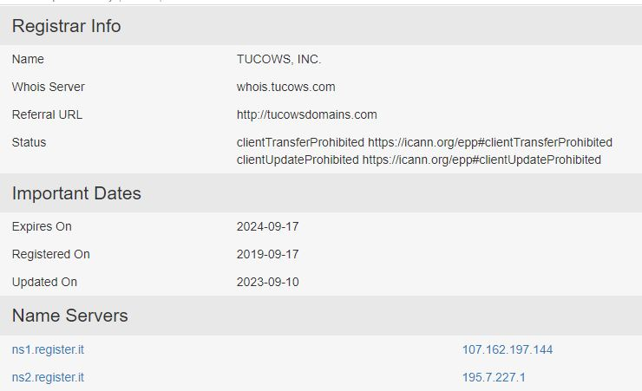**Italy:**

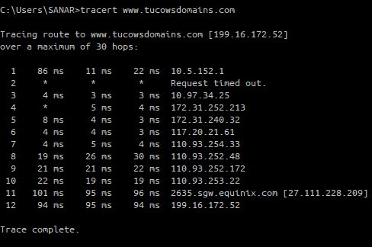

**United States:**

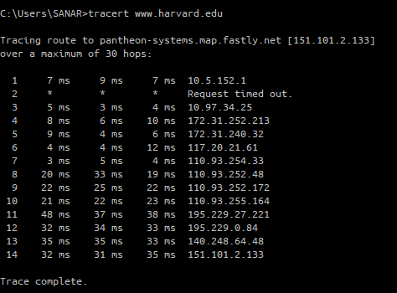

**Mexico:**



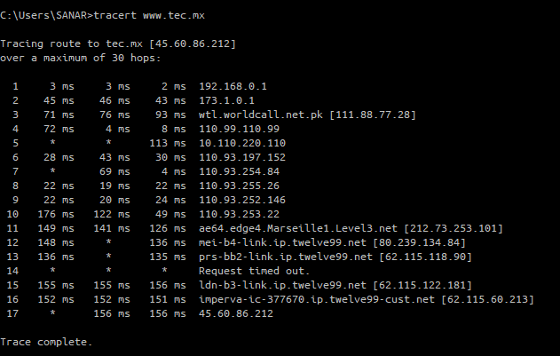

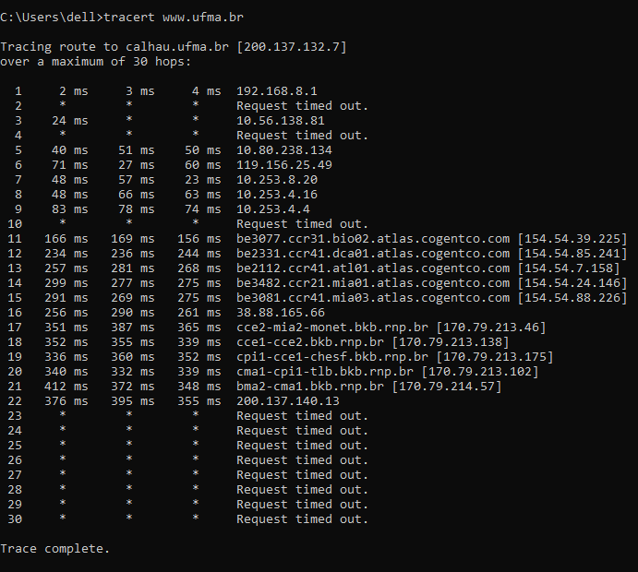**Brazil:**

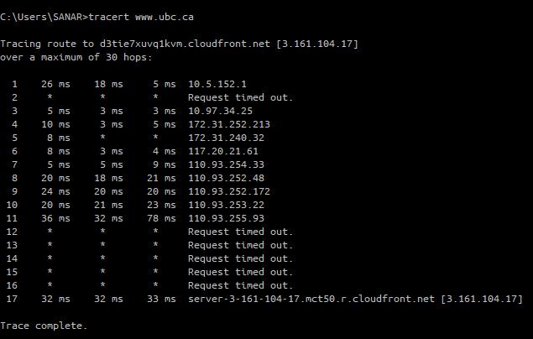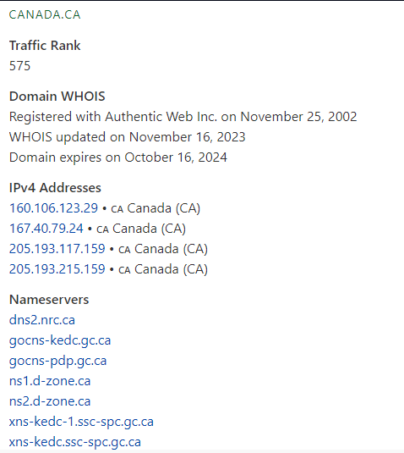**Canada:**

**Australia:**

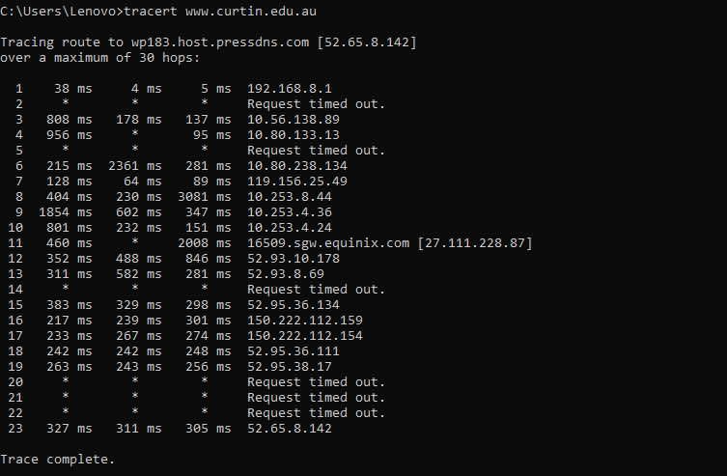

**New Zealand:**

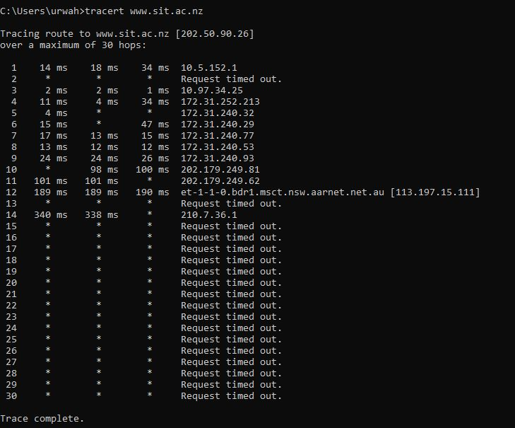

**South Africa:**

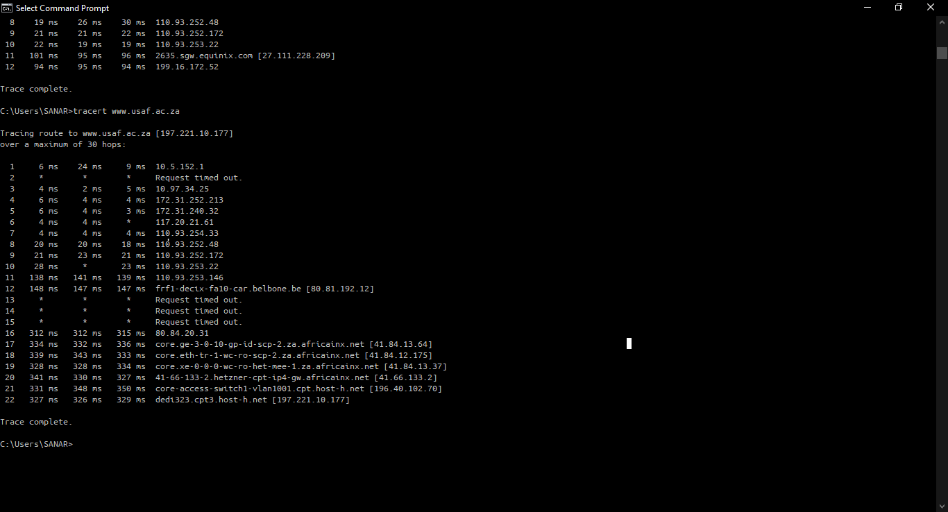

**2.** Write down at least three different observations about behavior of traceroute including an observation mentioning an “abnormal” output or something you are not expecting.

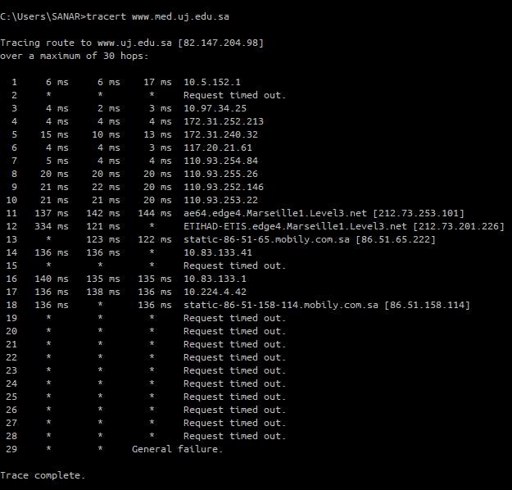**1. Incremental TTL Values:**

Traceroute sends packets with increasing Time-to-Live (TTL) values, revealing the number of hops to the destination.

**2. Varied Response Times:**

Traceroute shows round-trip times for each hop, reflecting network conditions and routing efficiency.

**3. Unresponsive Hops ("Stars"):**

Some routers may not reply, indicated by asterisks, obscuring the complete route and complicating tracing. Abnormal behavior, such as prolonged or inconsistent timeouts, can indicate network issues.

**3.** You can use traceroute to approximately find out earth diameter, can you explain how?

**Answer:**

Traceroute measures the **round-trip time (RTT)** of packets sent from a source to a destination, helping identify the routers along the path. To conceptually estimate the Earth's diameter, one might consider the time it takes for signals to travel through **fiber optic cables**, assuming the speed of light in the cables. By executing traceroute from one side of the Earth to the other, the total path distance can be approximated as twice the Earth's diameter. Dividing this total distance by **2** provides an estimate of the Earth's diameter.

However, this method relies on assumptions like a uniform speed of light in fiber optic cables and ignores network complexities, leading to a rough approximation rather than an accurate measurement. For precise measurements of the Earth's dimensions, dedicated **geodetic techniques**, such as satellite observations and astronomical measurements, are more suitable and reliable. Traceroute, while a valuable tool for network diagnostics, is not designed for or capable of providing accurate Earth dimension measurements.